

**Chat based Counselling Application**

**sayIT**

GROUP ID - CPG104

**Submission by:**  **Mentor:**

Sanket Bansal 101553008 Mr. Ashutosh Aggarwal

Shivam Sah 101511058

Pulkit Garg 101503172

# **1. Overview**

There comes a time when a person haphazardly need to have a resolving conversation with someone ( who is dealing with a quite similar situation) without being judged or having any fear of social defaming.

This project aims at providing a platform for the purpose of text counseling using chatbot and real time virtual environment counseling session .

It is inclusive of an android application which creates a VR group therapy session via real-time voice conversations and member’s masking with a corresponding facially dynamic & expressive avatar model thus maintaining anonymity around the table.

A cloud-AI based chatbot will be deployed to verify and categorize a group of individuals based on context of their problem extracted from either texts or voice messages entered, and responses to certain psychological tests as carried out by each user at application’s startup interface. The machine learning approach used here is to perform a sentimental analysis of processed voice signals by ensembling of various algorithms and a usage of third party APIs for textual context recognition though tentatively and the implementation is liable to get amended as the software development cycle executes.

**2. Need Analysis**

On day to day basis, we find ourselves surrounded by individuals, people we care about the most, people we admire and love, with these people we spend most of our time in sharing our feelings and creating memories.It’s been truly said that we can only be betrayed by whom we trusted most in those moments we sometimes find ourselves alone with no one to speak up our mind, many times we just don’t speak up our mind & self-pity due to hesitation and fear of being judged by another person, this leads to depression and other psychological anomalies after some-time of restrained emotions.

Not everyone experiences depression in the same way and for the similar reason. Some might not even realize that they are depressed, especially if they seems to other people as if they're managing their day-to-day life with ease. It doesn’t seem possible that someone can be smiling, chipper, functioning, and at the same time depressed due to which many a times depression remains undetected and without proper counseling and therapy.

Our application let user share their feeling and also try to calm the user hyperness down with soothing text and also motivate the person and encourage to stay strong and carry on in life. The user can also enter a group chat dedicated to users going through the same problems in life where they can have a conversation with each other and open up about their feelings anonymously in a undeliberate and carefree manner. The chat group will be managed by a bot trained well aided through artificial intelligence especially for kind of situation, members of the group are in and try to create a group therapy session. If a person is too depressed then on user permission we will refer the case to a psychologist to get individual attention.

Our app also lets you meet new people on a group chat you can send friendship hand to a user if they accept it you can send personal messages.Friends can see each other’s username but neither real name nor any kind of contact details will be displayed by us thus maintaining anonymity.

**3. Literature Survey**

Sentiment Analysis (SA) is an ongoing field of research in text mining field. Sentiment Analysis is the computational study of people’s opinions, attitudes and emotions toward an entity. The entity can represent individuals, events or topics. There are three main classification levels in SA: document-level, sentence-level, and aspect-level SA. Document-level SA aims to classify an opinion document as expressing a positive or negative opinion or sentiment. It considers the whole document a basic information unit (talking about one topic). Sentence-level SA aims to classify sentiment expressed in each sentence. Classifying text at the document level or at the sentence level does not provide the necessary detail needed opinions on all aspects of the entity which is needed in many applications, to obtain these details; we need to go to the aspect level. Aspect-level SA aims to classify the sentiment with respect to the specific aspects of entities.

#### Feature Selection methods can be divided into lexicon-based methods that need human annotation, and statistical methods which are automatic methods that are more frequently used. Lexicon-based method have many difficulties as reported by Whitelaw et al. Statistical approaches, on the other hand, are fully automatic. Point-wise Mutual Information (PMI) (T.M. Cover, J.A. Thomas) and Chi-squared methods (Aggarwal Charu C, Zhai Cheng Xiang) were most widely used in statistical approach.

#### Sentiment Classification techniques can be roughly divided into machine learning approach, lexicon based approach and hybrid approach (Diana Maynard, Adam Funk). The Machine Learning Approach(ML) applies the famous ML algorithms and uses linguistic features. The Lexicon-basedApproach relies on a sentiment lexicon, a collection of known and precompiled sentiment terms. It is divided into dictionary-based approach and corpus-based approach which use statistical or semantic methods to find sentiment polarity. The hybrid approach combines both approaches and is very common with sentiment lexicons playing a key role in the majority of methods. The text classification methods using ML approach can be roughly divided into supervised and unsupervised learning methods. The lexicon-based approach depends on finding the opinion lexicon which is used to analyze the text. There are two methods in this approach. The dictionary-based approach (Qiu and He) which depends on finding opinion seed words, and then searches the dictionary of their synonyms and antonyms. The corpus-based approach (Hatzivassiloglou and McKeown) begins with a seed list of opinion words, and then finds other opinion words in a large corpus to help in finding opinion words with context specific orientations. This could be done by using statistical or semantic methods**.**

#### Recent work for handling virtual counselling session:

#### Recent work by Kevin Clark and Tim Althoff [4] connected anyone in crisis to a psychologist via text-messaging through a 24/7 helpline after the session each user received feedback questions about the service. Data collected from experiment was used to analyse effectiveness of text-based counselling over conventional counselling and it was found that text-based counselling is almost equally effective.

#### Mitsuyoshi [5] suggested there is a relationship between these feelings of pleasure/displeasure and various emotions, and proposed a system to indicate anger, happiness, sadness, and calm, as well as the degree of pleasure/displeasure, which signifies emotional intensity. A technology to identify human emotions from prosodic information in speech has been established by Mitsuyoshi et al which was used in developing Sensibility Technology (ST) Emotion by AGI Inc This device incorporates a solid fundamental frequency estimation technique and an if/then rule-base derived from a massive emotion labelled speech database. ST detects over 200 emotion-characteristic parameters from spoken natural utterances and, based on the utterance frequency for these parameters and their speech patterns, displays in real time the percentage of anger, happiness, sadness, and calm contained in a person’s speech.

#### In our project we have used chat-based counselling over messaging, instead of psychologist user will chat to a bot trained over psychological responses as expected by user. We have tried to create real-time 3D group therapy session using web-VR and will be used for VRET therapy.

#### **4. Objectives**

4.1 Create virtual bot to counsel and suggest users based on emotional state

* chat bot will be developed which will respond the user’s text and emotional state by performing the sentiment analysis of the chat on the basis of available database of chat sentiments

4.2 User emotional state analysis:

* Determine the anxiety,depression,sadness and happiness level by analysing users speech voice, texts, facial expressions.
* Creating report of users mental health based on analysis.

4.3 Creating interface to connect with others emotions over a network:

* An interface will be created using which others speech voice and facial expression can be heard and visualize during counseling session.

4.4 Real time network of people counseling each other:

* Determine users in similar states on the real time basis.
* Connect these users on a network to share views and counsel each other by hearing speech voice and seeing facial expressions on a 3d model.
* Users can also share their thoughts and views using blogs and posts.

**5. Methodology**

5.1 Create virtual bot to counsel and suggest users based on it’s emotional state

* Tools and api :
* Android studio
* Google cloud function
* Nodejs
* Firebase
* Dialog-flow
* To create chat bots we will use android studio and google cloud functions which will work as a webhook and sent the user query text to google’s dialog-flow framework which uses database of counseling conversation to analyse query text and provide counselor reply as response to google cloud function and then to user in real time basis.Dialog-flow also provides suggestions related to organizations,gifs,songs to relieve the anxiety,depression and other causes

5.2 User Emotional state analysis

* Tools and api used
* Google vision Api
* Firebase
* Affectiva Api framework
* To analyse the user mental state famous Rorschach test will be implemented using images collected and stored in firebase.
* Speech voice analysis will be done to determine user present emotional state using affectiva api framework.
* Facial expressions are detected through images taken during counselling session or during app usage session these expressions are analysed on real time basis by applying google vision api.
* Based on these analysis a report will be created which would be scored on the basis of parameters provided by the field experts which will be stored in a Nosql database.
* On the basis of score of users report user will get suggestions such as counselling with experts or online social groups to join of those data will be retrieved through the database.

5.3 Interface to share emotions with others over network

* Tools used
* React VR
* Firebase
* Google cloud
* Android
* Interface will be an virtual environment created for VR using react VR to simulate the counselling session.
* A simulating model will be developed using react VR framework which will be used to show users facial expressions to other people during counseling session on real time basis .It also helps to pertains individual identity hidden from other as per individual choice
* A speech listening interface will be created in android environment to listen users audio and simulate react VR face model.
* All data related to conversations during counseling will be stored on database from where it will be pipelined with google cloud support to perform analysis .

5.4 Real time network of people counseling each other

* To connect people with same emotional state at present for counseling session we will be determining people going through same state using firebase on real time basis.
* Sockets concept will be implemented for real time connections among people.
* Some rules needs to be regulated by individual during conversation session which will be monitored by the app.

**6.** **Work plan**

The following work plan will be of 8 months from March-october

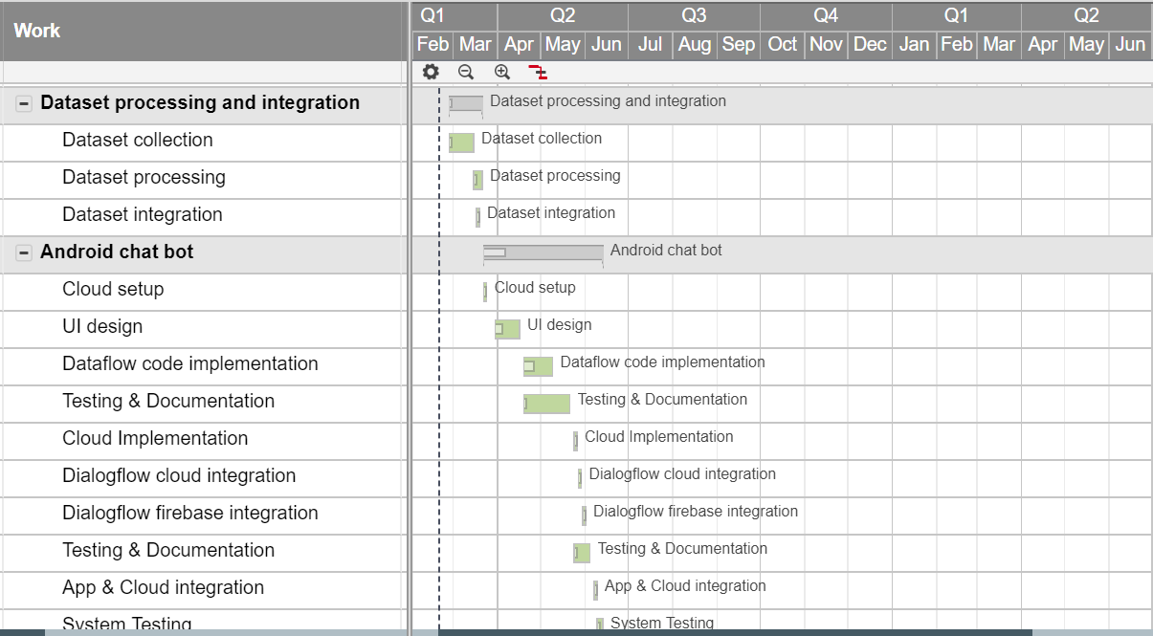

Figure 6.1- Work plan for February to June which will be mainly Android Development and data collection and preparation

# 

# Figure 6.2-Work plan for June to November which will be used for developing WebVR app

# 

Figure 6.3-Work plan for November to December which will be used for testing

# 

# 7. Project Outcome & Individual Roles

## 7.1 Project Outcome

An android application will be presented as an ultimate outcome. Chatbot text counseling and real time virtual environment counseling session will be the main features of the app.

## 7.2 Individual Roles

Refer to table in figure 7.2 for the set of processes done by each member

|  |  |
| --- | --- |
| Sanket | Dataset Integration, Cloud setup, Data flow code implementation, Dialog-flow cloud integration, Dialog-flow firebase integration, System Testing, API documentation reference, 3D environment development, Avatar facial expression rendering, Cloud data storage integration, App webview VR rendering, Testing and documentation, test demos. |
| Shivam | Dataset processing, UI design, Cloud Implementation, App and cloud integration, System Testing, Data Integration, Cloud data processing and analysis, Real time user data synchronization, Server-client data flow, Testing and documentation, create demos, Create presentation. |
| Pulkit | Dataset collection, Environment setup, 3D avatar model creation for web-VR, User speech voice development & integration, User facial expression data pipeline, ensembling Cloud ML APIs predictions, Speech and expression synchronization, System testing, Create poster. |

Figure 7.2 - table - Individual Roles

1. **Course Subjects**

* IMS

- For connecting chat data to server

* Android Programming

- For developing android application for chat

* Computer Vision and Virtual Reality

- Developing 3D avatar and virtual therapy sessions

* Image Processing

- Capturing Emotion on face used for developing 3D avatar

* Natural Language Processing

- Sentiment analysis and text processing

* Software development and testing

1. **References**

[1] R. CALVO, D. MILNE, M. HUSSAIN and H. CHRISTENSEN, "Natural language processing in mental health applications using non-clinical texts", 2018. .

[2] W. Words?, "Natural Language Processing (NLP) in Psychotherapy", *Society for the Advancement of Psychotherapy*, 2018. [Online]. Available: http://societyforpsychotherapy.org/words-natural-language-processing-psychotherapy/. [Accessed: 20- Feb- 2018].

[3] "How to help someone feel better: NLP for mental health - The Stanford Natural Language Processing Group", *Nlp.stanford.edu*, 2018. [Online]. Available: https://nlp.stanford.edu/blog/how-to-help-someone-feel-better-nlp-for-mental-health/. [Accessed: 20- Feb- 2018].

[4] B. Cook, A. Progovac, P. Chen, B. Mullin, S. Hou and E. Baca-Garcia, "Novel Use of Natural Language Processing (NLP) to Predict Suicidal Ideation and Psychiatric Symptoms in a Text-Based Mental Health Intervention in Madrid", 2018. [Online]. Available: https://www.ncbi.nlm.nih.gov/pmc/articles/PMC5056245/. [Accessed: 20- Feb- 2018].

[5] "Sentiment analysis and affective computing for depression monitoring - IEEE Conference Publication", *Ieeexplore.ieee.org*, 2018. [Online]. Available: http://ieeexplore.ieee.org/document/8217966/. [Accessed: 20- Feb- 2018].

[6] "Emotion recognition on speech signals using machine learning - IEEE Conference Publication", *Ieeexplore.ieee.org*, 2018. [Online]. Available: http://ieeexplore.ieee.org/document/8070805/. [Accessed: 20- Feb- 2018].